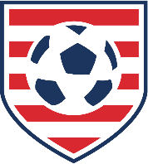
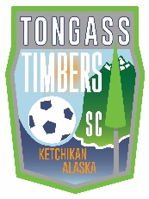
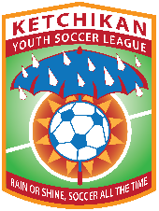
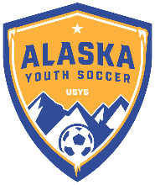
Alaska Youth Soccer Association
Affiliate Member Club/ Leagues
Health Status Agreement
(Release of Liability and Assumption of Risk Agreement)

In consideration of being allowed to participate in any way in the program, related events, and activities, I the undersigned, and acknowledge: there are risks to my child of exposure to directly or indirectly arising out of, contributed to, by, or resulting from an outbreak of any and all communicable disease, and certify as follows:
- I/We have not had a fever in the last 14 days.
- I/We have not had a cough and/or experienced any difficulty breathing/shortness of breath in the last 14 days.
- I/We have not knowingly had contact with a person confirmed with COVID-19 in the past 14 days.
- I/We have not traveled outside the United States within the last 14 days.
- I/We have not traveled outside the State of Alaska within the last 14 days.
- I/We have not tested positive for COVID-19.
- If I/We have tested positive for COVID-19, I/we have fully recovered and have been released to return to work/play as normal by my medical doctor.

RELEASE FROM LIABILITY:
This is to certify that I, as parent/guardian with legal responsibility for this participant, do consent and agree to his/her release, and on my behalf, HEREBY RELEASE, INDEMNIFY, AND HOLD HARMLESS THE Alaska State Youth Soccer Association, its officers, officials, affiliates, agents and/or employees, other participants, sponsors, advertisers, and, if applicable, owners and lessors of premises used to conduct the event programs and activities of US Youth Soccer and Alaska State Youth Soccer, from any and all claims, demands, losses, and liability arising out of or related to any ILLNESS, INJURY, DISABILITY OR DEATH I may suffer, WHETHER ARISING FROM THE NEGLIGENCE OF THE RELEASEES OR OTHERWISE, to the fullest extent permitted by law.
I agree to notify my club and league immediately if my child becomes ill for any reason and / or we have tested positive for COVID-19. I have read this Release of Liability and Assumption of Risk Agreement, fully understand its terms outlined, understand that I have given up substantial rights by signing it, and sign it freely and voluntarily without any inducement.
_________________________________________________ ________________
Player Name Age/Grade Group

X________________________________________________ __________________ __________
Parent/Guardian Signature Phone Number Date

Alaska Youth Soccer
200 W. 34th Ave # 21
Anchorage AK 99503
alaskayouthsoccer@gmail.com
(907) 887-6550

