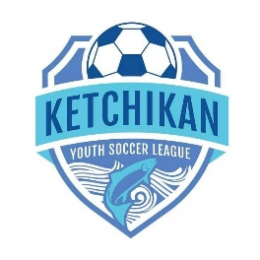
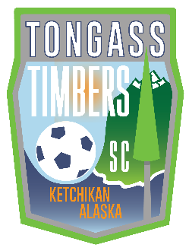
KETCHIKAN YOUTH SOCCER LEAGUE
FINANCIAL AID FORM

The Ketchikan Youth Soccer League and Tongass Timbers SC provide financial assistance when funds are available. Some sources of funds are designated for families with a demonstrated financial need and some sources of funds do not specifically require conditions.
The financial aid can be used for KYSL and TTSC related fees (i.e. club/league registration and travel) up to a total of $300.00 a year per player.
It is most important to the KYSL Board of Directors that your information be secure and confidential. We are here to assist and encourage participation in the sport of soccer in a positive way.
The information requested and contained in the form is never shared with any individual outside of current KYSL Board Members and paid staff.
NAME OF PLAYER: ___________________________________ DOB: ______________
NAME OF PARENT/GUARDIAN: ____________________________________________
CONTACT PHONE NUMBER: _____________________________
REQUESTED FOR: ☐ TTSC Club Fee $______________ ☐ KYSL/TTSC League Fee: $_____________
☐ Travel Fare: $_____________ Total: $_____________(not to exceed $300/yr.)
Ketchikan Indian Community members may be eligible for scholarships for registration & league fees which is recommended to maximize financial aid.
ANNUAL HOUSEHOLD INCOME (REQUIRED):
Which category best reflects the most recent household size/income:
Household Size/Annual Income
☐ 2 PERSON/$55,950 or less ☐ 3 PERSON/$62,950 or less ☐ 4 PERSON/$69,900 or less
☐ 5 PERSON/$75,500 or less ☐ 6 PERSON/$81,100 or less ☐ 7 PERSON/$86,700 or less
☐ 8 PERSON/$92,300 or less ☐ None of the above (may exempt the request from income-based funds)
☐ I do not wish to provide (this will exempt the request from income-based funds)

Parent/Guardian Signature: __________________________________ Date: ___________

For KYSL Use Only: Approved on: _______/_______/___________ Approved Amount: $___________
KYSL Scholarship Committee Initials: ________ ________ ________ (2 of 3 members required)

